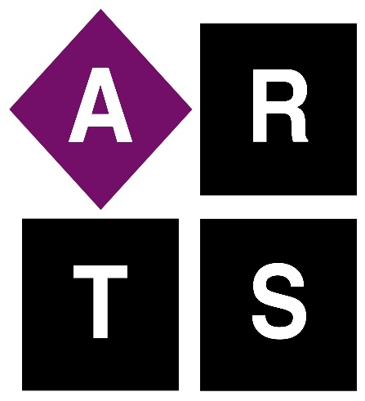
“Choose your own Adventure” up to date bid list!
Plane ride with Jake Bell
Tour and tasting for four at Wilderness Road Distillery
Tickets to performance at Norton Center next season
Shamrock camp fee at West T. Hill Community Theatre
Family membership to Shaker Village
2 entry fees to the Run for the Brass
Private tea tasting for four with Bruce Richardson at Elmwood Inn Fine Teas
Picnic lunch from Southern Plate Catering
Ride on firetruck in Christmas parade
Four tickets to Scarlet Cup Theater next season
Two season passes to Pioneer Playhouse 2022 season
Guest host on the Joe Mathis radio show
Stay at Clemens Caldwell Airbnb
Talk and tasting with Aaron Ranson at Dry Stack Café and Roastery for up to 10
Bird watching with Mark and Joni Morgan for two to five persons
Two passes to Starry Night Studio at Art Center of the Bluegrass
Racquetball tips with professional Dina Moreland
One hour racquetball challenge for three with professional Dina Moreland
Round of golf and carts for three with Charlie Perry at Bright Leaf
Authentic ravioli cooking class for up to three with Kay Arnold
Family pool pass to Bunny Davis Pool
“Coffee with Words” with writer Patsi Trollinger
“Love the Creek” walk (1-3 three along historic Clark’s Run with Preston Miles
Five games and shoe rentals at Bowlarama
Glass blowing for two wines or bourbon glasses at Flame Run
Explore instrument building with Kasey Webb
Create your own art from found objects with Brandon Long
Experience a cottage/cut flower garden from flower to vase wit Elspeth Cobb
Spend a movie viewing for up to two with Bruce Caudill

